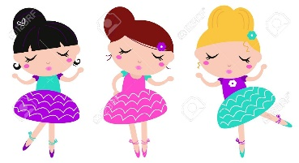**DDD FEES/POLICIES/DRESS CODE Pg. 1**

Email:[debrasdancingdarlings@yahoo.com](mailto:debrasdancingdarlings@yahoo.com) [www.debrasdancigdarlings.com](http://www.debrasdancigdarlings.com) 972.754.1253 Call/Text

**FEES/PAYMENTS:Registration fee $25.00 per student/ Monthly tuition $55.00.**

**\*Sibling discount is $25.00 if they are in the same class.**

**\* Pay by Cash, Check left at front desk of school or VENMO.**

**VENMO address- @Debra-Montalvo-3**

1. DDD accepts checks or cash Venmo only. Checks are made payable to Debra’s Dancing Darlings.
2. Payments must be made on the 1st of the month. If payments are received after the 10th of the month, a $25.00 late fee will automatically be added to bill.
3. Monthly reminders will be sent via email when needed.
4. All fees are Non transferrable
5. All fees are Non refundable
6. Return check fee/INSF $30.00

***Withdrawal from Class:*** *Please contact Mrs. Debra via email or phone at least 1 WEEK before the FIRST of the next**month. If not received, then your account will be charged for the following month.*

***Holidays and Closings:*** DDD follows the Preschool, Daycare, Montessori, or Community Centers Holidays and Closings. Please check your email or the DDD Facebook page for reminders.

**Parent’s Responsibility:** It is the responsibility of the parent to be aware of all class activities, such as observation days, recitals and dates the class is open or closed. DDD will send notes home with the student. It is the parent’s responsibility to regularly check your email, our DDD website or Facebook page to ensure they are informed. It is also the responsibility of parent to inform DDD of any personal address or telephone number change.

**Accident/Injury:** Parents or legal guardians waive the right to any legal action for any injury sustained on Preschool, Montessori, Daycare, or Community Center property resulting from normal activity conducted by the students before, during and after the dance class time.

**Recital:** $125.00 per student (Includes- Recital Fee, Recital Costume and 2 Complimentary Tickets). Our recital performance is usually in the month of May or June.

**Photo Release:** **DDD** is hereby granted permission to take pictures of the students and use for advertisement or display purposes only.

**DRESS CODE: Pg. 2**

Ballet Shoes Tap Shoes Jazz Shoes 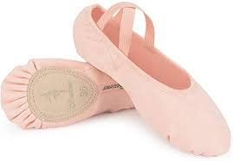 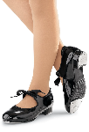 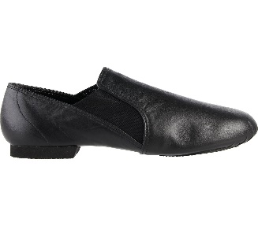

Leotard w/skirt Leotard Dance Tights Leggins

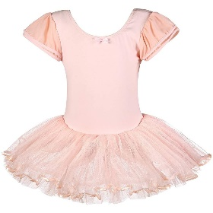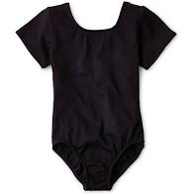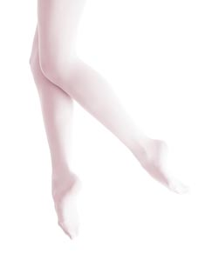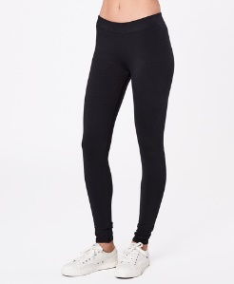

Boys Shorts Boys T-shirt Boys Sweatpants Boys Tap Boys Ballet

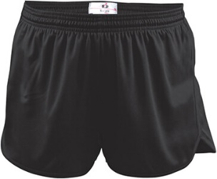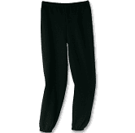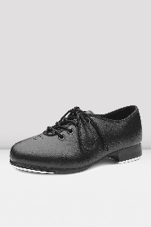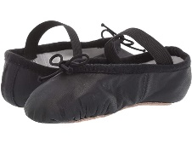

**PREBALLET/TAP or PREBALLET/CREATIVE MOVEMENT CLASS:** A solid colored leotard, pink tights, and pink ballet shoes (Please no pink silk slippers). Dance skirt is optional or Leotard with attached skirt.

**JAZZ/HIP HOP or JAZZ/BALLET CLASS:** A solid colored leotard, black leggings, and black jazz shoes.

**BOYS DANCE CLOTHES:** A solid color or white t-shirt with black shorts or black leggings or sweat pants.

**BOYS BALLET and TAP SHOES**: Black Ballet shoes and/or Black Tap Shoes

**HAIR:** All students must have their hair in a ponytail or out of the face and neck area when in class.

*Dance clothing can be found at Walmart, Target, or a Dancewear store. Dance Shoes can be found at Payless, Academy Outdoors, or a Dancewear store.

**Online Stores:** Discount Dance Supply, Dancewear Solutions and Amazon!